

**KABARAK UNIVERSITY**

**UNIVERSITY EXAMINATIONS**

**MAIN CAMPUS**

**FIRST SEMESTER, 2017/2018 ACADEMIC YEAR**

**EXAMINATION FOR THE DEGREE OF BSC CS**

**COMP 329-VISUAL PROGRAMMING**

**STREAM: [Y3S2] TIME:**

**EXAMINATION SESSION: AUGUST DATE:** 2018

**INSTRUCTIONS**

* **Answer QUESTION ONE (COMPULSORY) and any other TWO questions**
* **Do not write on the question paper**
* **Show your working clearly**

**QUESTION ONE 30 MARKS**

1. Unlike VB6, Visual Basic 2010 is an object oriented programming language, define the following terms in relation to object oriented programming.
2. Object (2 marks)
3. Class (2 marks)
4. Instance (2 marks)
5. List at least FOUR controls and their functions as used on VB2010. (4 marks)
6. Label control:
7. Button Control
8. Picture box control
9. Label control:
10. Write a VB code that changes the background color of a form. (5 marks)
11. Using an Example, explain how suffixes are used in VB 2010. (5 marks)
12. Study the following output and write a code for them. (5 marks)

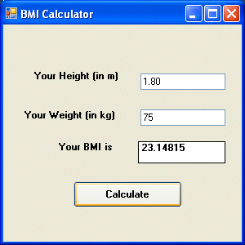

1. ShowRecords () is a sub procedure created to show data in the text boxes. Write a code to demonstrate how this works. (5 marks)

**QUESTION TWO 20 MARKS**

* 1. Study the following output and write a code. (6 marks)

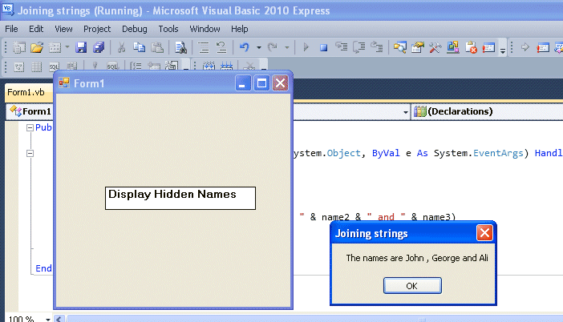

* 1. Write down at least FOUR rules for writing variable names in VB 2010. (4 marks)
  2. A variable is a temporary memory location. Explain how a variable is declared in VB 2010 (5 marks)
  3. With the help of an example, write a note on constants as used in VB2010. (5 marks)

**QUESTION THREE 20 MARKS**

1. Write a code for Pythagoras theorem. (5 marks)
2. With the help of an example, discuss about the if.. statement. (5 marks)
3. List down FOUR types of loop formats. (4 marks)
4. Write a program that shows implementation of a DO loop. (6 marks)

**QUESTION FOUR 20 MARKS**

1. Study the following output and write a code for it. (5 marks)

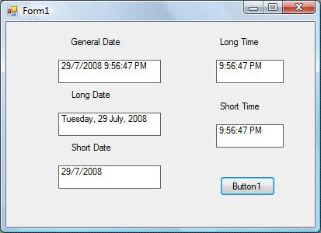

1. A Check box is a VB 2010 control that allows the user to select one or more items by checking the check box/check boxes concerned. Write a program that demonstrates the use of a checkbox. (6 marks)
2. Study the following output and write a code. (5 marks)

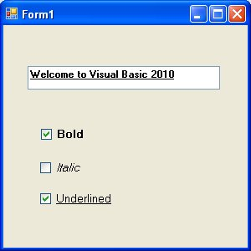

1. Explain the reason as to why VB2010 is both event driven and object oriented.

(4 marks)

**QUESTION FIVE 20 MARKS**

1. Write a note on error handling using Try…Catch… End Try Structure. (6 marks)
2. Explain why error handling is important in VB 2010 (4 marks)
3. Explain how to establish a connection to a data source using SQL ConnectionString property. (5 marks)
4. Write a VB code for adding new record or new row to a database table. (5 marks)